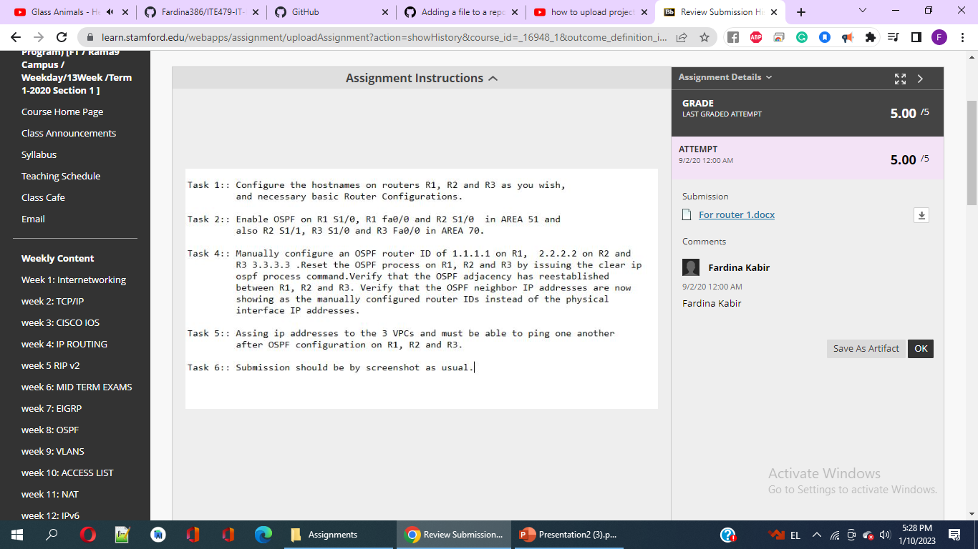

For router 1.London:

1.

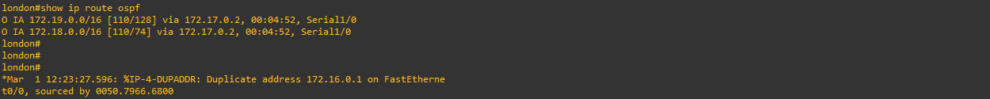

For router2:

F

